SOFTWARE REQUIREMENTS SPECIFICATION
TastyTracker
Julie White (2832202)
1.0 Introduction
This document outlines the data, functional, and behavioral requirements for the software to be created, TastyTracker. TastyTracker is an inventory management application specifically designed to manage household food inventory, create shopping lists, and obtain recipes.
1.1 Goals and objectives
The main objective of TastyTracker is to provide users and their households with an efficient way to track food items, manage their quantity, and create a shopping list for desired items or items low in quantity. Additionally, users should be able to find recipes and add missing ingredients to their shopping list, as well as find recipes that are createable based on their household’s current inventory.
1.2 Statement of scope
TastyTracker keeps track of food items and ingredients within a household’s fridge and pantry. Users can adjust the quantity of these items when adjustments need to be made. Also, the user can create a shopping list. After shopping, the user should be able to quick add the shopping list items/quantities to their current household inventory. The shopping list can have items added to it multiple ways—via the inventory screen (when items get low), via search, or via recipe search. Users can search for recipes they would like to make and if they are missing ingredients, they can opt to add those missing to their shopping list. Users can also be able to filter recipes to look at only recipes that are currently available based on current inventory.
Major Inputs:
- User credentials (specifically username and password)
- Food items in household and their quantities
- Items to add to shopping list
- Recipes to search
Processing Functionality:
- Update ingredient quantity
- Identify missing ingredients from recipes
- Sync data for multiple users in household
- Edit and update grocery list
- Add items/quantities from shopped to current inventory
Outputs
- Household food inventory
- Shopping list
- Individual Recipes
- List of recipes based on available ingredients
1.3 Software context
TastyTracker will serve as a household inventory management tool for tracking food, generating shopping lists, and finding recipes. It is intended to be used by users/households wanting to manage inventory status and grocery needs more efficiently and reduce consumer costs (from unnecessary repurchasing of items) and unintended running out of items (from losing track of inventory).
1.4 Major constraints
- Resource Constraints:
  - Team size- the development team is comprised of one member, which limits the pace at which features can be developed and tested.
  - Time Availability- The developer also works full-time in addition to working on this project, which restricts the amount of time available to work on the project.
  - Development Tools- the choice of development environments, IDEs, and libraries will be restricted to ones that the developer is already familiar with to help with time management.
- Technical Constraints:
  - Smartphone Application- TastyTracer is meant to be used on a smartphone, so the software must be available on either Android or iOS (ideally both, but prioritization to one is likely)
  - Data Synchronization- the app allows multiple users to modify the same household inventory, so ensuring real-time synchronization of data across devices is important. Avoiding race conditions and ensuring data integrity is vital.
- Timeline Constraints:
  - Academic Calendar- TastyTracker is being developed within an academic context, so the development must abide by the academic schedule. The final project is due on December 5th and an initial version is due on November 14th.

- 2.0 Usage scenario
This section provides a usage scenario for the software. It organized information collected during requirements elicitation into use-cases.
2.1 User profiles
- Head of household (HH)- this user is the “admin” of the household. This user can add items to grocery list and household inventory without approval. They are able to adjust item quantity and look up recipes. They can filter recipes by item availability and add missing items from recipes to the grocery list. They may grant all inventory management privileges to another member of the household, but only the head of household can grant privileges and accept requests.
- Household member with privileges (MWP)- this user does not have “admin” privileges, but they do have inventory management privileges. They can do everything the head of household can do except grant another user inventory management privileges and accept inventory requests.
- Household member without privileges (MWOP)- this user does not have “admin” privileges. They can decrease item inventory and look up recipes (both filtered and unfiltered). However, this user cannot add items to the household inventory or to the grocery list without head of household approval.
2.2 Use-cases
- Add Food Item to Inventory
  - HH and MWP can add items and current quantity to inventory
- Decrease Quantity of Food
  - HH, MWP, and MWOP can decrease the quantity of a food item
- Increase Quantity of Food
  - HH and MWP can increase the quantity of items in the inventory.
- Add Item to Shopping List
  - HH and MWP can add items to the shopping list when items are low, from recipe requirements, or by typing in name/quantity.
- Add Item from Shopped List to Inventory
  - HH and MWP can remove items from shopped shopping list and automatically add them to the inventory.
- Recipe Search
  - HH, MWP, and MWOP can search for a recipe
- Filter Recipe Search Based on Inventory
  - HH, MWP, and MWOP can search for a recipe based on current inventory.
- Add a MWP
  - Only HH can give another household member MWP designation.
- Request To Add Item to Shopping List
  - MWOP can request to add an item to the shopping list. The request is sent to the HH for approval.
2.3 Special usage considerations
  - Multiple Device Syncing: Ensuring real-time syncing of food inventory across devices used by multiple household members is crucial.
  - User Permissions: Ability to track who has which permissions.
  - Requests: Make sure HH is notified of requests.
3.0 Data Model and Description
This section describes the information domain for the software
3.1 Data Description
TastyTracker will manage multiple data objects that are central to the functionality of the system. These objects include user profiles, food items, shopping list items, recipes, and requests. Each object will store specific attributes to ensure the proper functioning of the app and allow different types of users to interact with and modify the household inventory and shopping list.
3.1.1 Data objects
- User Profile: each profile represents each individual user of the app and holds information relevant to their role and permissions in the household
  - Attributes
    - Household name: Nickname for user to be used for easier household identification.
    - Username: A unique identifier used by the user to log in
    - Password: Secure identifier used to log in
    - Role: Specifies the user’s role
    - Privileges: Boolean attribute that indicates whether the user has inventory management privileges
- Food Item: object stores information about each item in the household inventory. Depending on privileges, users can add, modify, or delete these items.
  - Attributes
    - Name: name of the food item (e.g., “Carrots”)
    - Quantity: quantity of the food item
    - Unit: The unit in which the quantity is measured (e.g., gallon)
- Shopping List Item: object tracks items that the household needs to purchase, based on manual addition or recipe requirements
  - Attributes
    - Name: Name of the item to be purchased
    - Quantity: Quantity to be purchased
    - Unit: The unit in which the quantity is measured
    - Purchased: Boolean attribute indicating whether the item has been purchased.
- Recipe: recipe object stores information about recipes that can be viewed and filtered by available ingredients
  - Attributes
    - Title: Name of recipe (e.g., “Spaghetti”)
    - Ingredients: A list of ingredients required to make the recipe.
    - Instructions: step-by-step instructions on how to prepare the recipe.
    - Missing ingredients: A list of ingredients not present in inventory.
    - Matched ingredients: A list of ingredients that are available in the inventory.
- Request: this object stores information about the items that MWOP users have requested to be added to the household inventory or shopping list.
  - Attributes
    - Requested By: Household name of MWOP that made the request
    - Requested Item: Item the user wants to add to the inventory or shopping list.
    - Status: status of the request (pending, approved, or rejected)
3.1.2 Relationships
The following relationships between data objects define the interaction between user and the TastyTracker app:
- User Profile ↔ Household: A user belongs to a household and can manage the shared inventory and shopping list according to their role (HH, MWP, MWOP).
- Household ↔ Food Item: The household manages multiple food items in its inventory.
- Household ↔ Shopping List Item: The household manages multiple shopping list items.
- Recipe ↔ Food Item: Recipes reference the food items available in the household inventory to determine which recipes can be made.
- Request ↔ Household: Requests are made by MWOP users and handled by the HH.

3.1.3 Complete data model
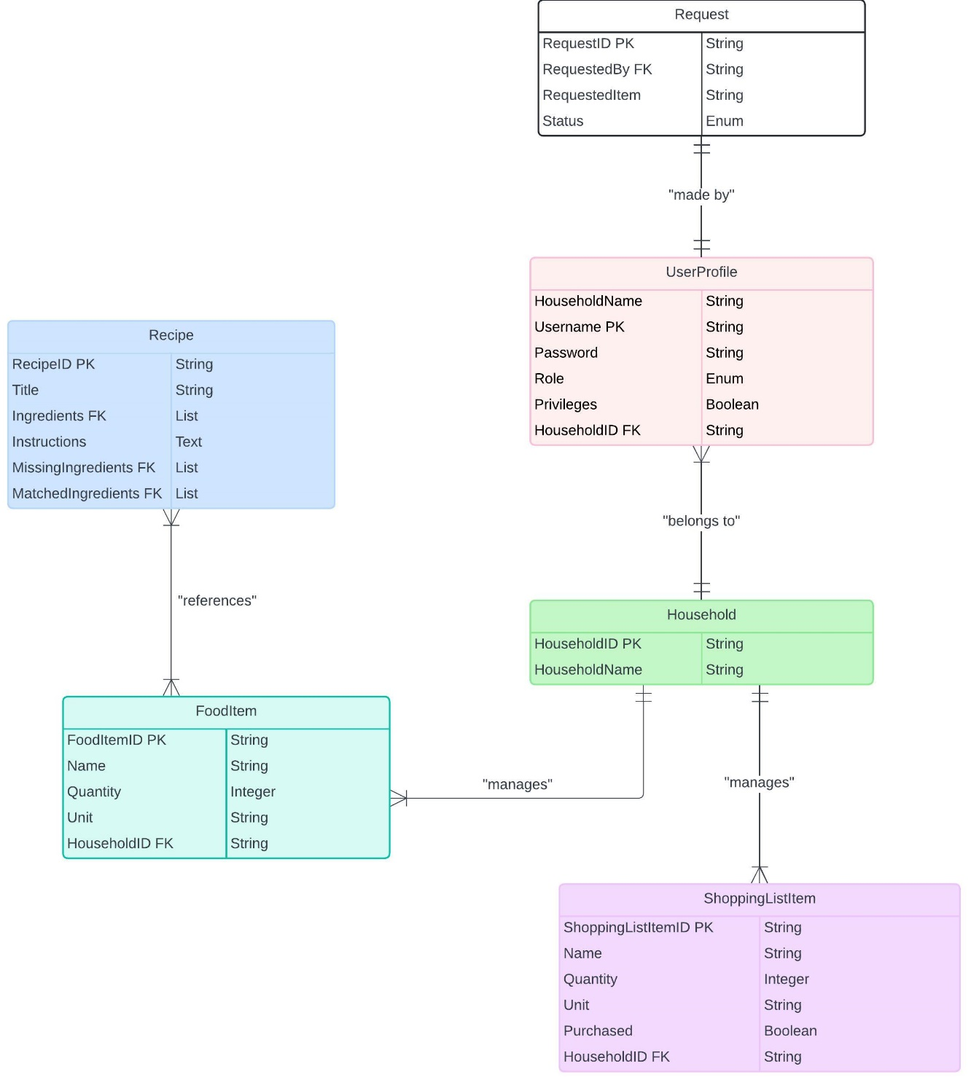
This ERD was created using Lucidspark.com following a crow’s foot notation (learned in Database Concepts here at Cleveland State University).
3.1.4 Data dictionary
- User Profile
- Household Name: String, nickname used for identification within a household.
- Username: String, unique identifier for logging in.
- Password: String, securely encrypted password.
- Role: Enum, possible values include HH, MWP, MWOP, specifying user privileges.
- Privileges: Boolean, true if the user has inventory management privileges.
- Food Item
- Name: String, the name of the food item (e.g., "Carrots").
- Quantity: Integer, the amount available in inventory.
- Unit: String, the unit of measurement (e.g., gallon, kilogram).
- Shopping List Item
- Name: String, the name of the item to be purchased.
- Quantity: Integer, the amount needed for shopping.
- Unit: String, the unit of measurement for the item.
- Purchased: Boolean, indicates whether the item has been purchased.
- Recipe
- Title: String, the name of the recipe (e.g., "Spaghetti").
- Ingredients: Array of Strings, a list of required ingredients.
- Instructions: String, step-by-step instructions for preparing the recipe.
- Missing Ingredients: Array of Strings, ingredients not available in the current inventory.
- Matched Ingredients: Array of Strings, ingredients available in the current inventory.
- Request
- Requested By: String, the household name of the MWOP who made the request.
- Requested Item: String, the item that the MWOP wants to add.
- Status: Enum, possible values include "Pending", "Approved", and "Rejected", indicating the request status.

4.0 Functional Model and Description
This section outlines the core functionality of TastyTracker, including the major functions and the software interfaces to other systems/users.
4.1. Description of Major Functions
Each requirement is uniquely identified.
4.1.1 Requirement 1: Manage Food Inventory
  - Users (HH, MWP) can add, edit, or delete food items in the household inventory, updating quantities as needed.
4.1.2 Requirement 2: Manage Shopping Lists
  - Users (HH, MWP) can add items to the shopping list, either manually or by recipe search. HH and MWP can also mark items as purchased
4.1.3 Requirement 3: Recipe Integration
  - Users (HH, MWP, MWOP) can search recipes and filter based on current inventory.
4.1.4 Requirement 4: Request Item
  - MWOP users can request to add items to the shopping list or inventory
4.1.5 Requirement 5: Handle Request
  - HH can accept or deny MWOP request to add items to shopping list or inventory.

4.2 Software Interface Description
The software interfaces with external databases, systems, and users to enable data processing as well as interaction with the app.

4.2.1 External machine interfaces
TastyTracker will interface with smartphones, specifically targeting Android and iOS operating systems.
4.2.2 External system interfaces
TastyTracker will rely on external database for data storage. A relational database (most likely MySQL) will store most data objects, including user profile, food items, and shopping list items. Recipes will also be pulled from an external API so that the app does not have to permanently store information on all recipes, but can cache them temporarily during a user session.
4.2.3 Human interface
The app will provide an intuitive and user-friendly interface for managing food inventory, creating shopping lists, and searching for recipes. The UI will be designed with mobile-first principles to ensure usability on smartphones.
5.0 Restrictions, Limitations, and Constraints
Several restrictions, limitations, and constraints affect the development and implementation of TastyTracker:
- Platform Limitation: Initially, the app will prioritize one smartphone platform (either Android or iOS) due to time and resource constraints.
- Team Size: The project is developed by a single person, which limits the speed of development and testing.
- Time Constraints: Due to the academic schedule, the project must be completed by December 5th, with an initial version due by November 14th.
- Data Integrity: Given that multiple users may update the same inventory data concurrently, ensuring data synchronization and avoiding race conditions is a high priority.
- Resource Constraints: The development tools, libraries, and frameworks used will be restricted to those already familiar to the developer to ensure efficient use of time and resources.

